HOW TO CONDUCT A PINEWOOD DERBY

Why We Have a Pinewood Derby
Racing in a Cub Scout Derby is fun, and an opportunity for scouts to learn craft skills, the rules of fair play, and good sportsmanship, skills all boys need to learn to become successful in life.

Schedule
Action | When | Who
Decide on a date and reserve the MPR, usually on a Sunday in January. | Start of school year | Committee Chair
Order car kits, reflecting the number of scouts plus 20 more for siblings | November | Awards Coordinator
Recruit volunteers for the Derby Committee. Need about 4 volunteers for the core Derby Committee, 4 more to help on the day of. | November | Volunteers Coordinator / Committee Chair
Hand out car kits to Den Leaders to distribute at the end of the meeting, so kids don’t open boxes and spill contents. | December Pack Meeting | Awards Coordinator
Have Pack Photographers cover the event | December | Volunteers Coordinator / Committee Chair
Derby Committee meets and confirms job assignments. | December | Derby Committee
Order trophies, medals, certificates, and patches. | December | Awards Coordinator / Derby Committee
Announce, post and email Pinewood Derby rules, instructions, workshop, and race date. | After December Pack Meeting | Cub Master, Web Master, Secretary
Derby Committee meets with Pack and Den Leaders, shares plans, and finalizes details. | First week in January | All Leaders
Order pizza for the Pack. For 75 scouts, 15 pizzas (6 pepperoni and 9 cheese), cut into 16 smaller slices. | Week before the race | Derby Committee
Car Impound – make sure race cars qualify. Assign each car a number and insert the car’s number in the Derby scoring system. | Day before the race | Derby Committee
Race Day – set up the race area and test the track, timing devices, and Derby race tracking programs. | 3 hours before the race | Derby Committee
Race Day – run the race and celebrate achievements! | Race day | Derby Committee and Cub Master
Race Day – cleanup | Race day | Everyone available

Book It
The Pinewood Derby Race is usually scheduled at noon on a Sunday in January. If possible, try to avoid football championship games for better turnouts. The Pack 1776 Committee Chair should book the Coyote Creek MPR from 9:00 am to 3:00 pm at the beginning of each Scouting year. This will give us enough time to set up, host the event, and clean up.

Announcements
Announcements should go out as soon as the kits are distributed. Derby Committee should email the Web Master on what to post on the website. Here’s an example, search the Pack Website for other past postings. Don’t forget to include the rules!
Date/Time: Saturday, January 24th, 2016 Noon to 3pm
Location: Coyote Creek MPR
Attire: Class A
Bring: Reusable water bottle and Readiness to cheer on your fellow scouts

Our Annual Pinewood Derby will be held on January 24 from noon to 3 PM in the MPR! There will be racing, design competitions, and pizzas. Please be conservation minded and bring your own reusable bottle - fresh filtered water available from the nice refillable station in the MPR. We will once again have an open class for adults and siblings. Additional kits may be purchased for $5. Contact Surat Perez to purchase more kits. Wear your Class A uniform!

The mandatory inspection and car impounding is on January 23 from 10:00 AM to 1:00 PM at Ajay's Home.

Even though Pinewood Derby car is a team project for scouts and their adults, we encourage scouts to do as much of the car building as possible. For those new to scouting or just need a refresher course, here are some helpful websites:
- How to Video
- Design Ideas
- How to Tips and Templates
- Online Car Designer

If you need help cutting the wood block, you can take it to Alamo Hardware on Sunday, January 10 at 6:00 PM or Monday, January 11 at 4:00 PM. The store staff will cut each car for $5. You can also use their equipment to sand, align the wheels, and fine-tune various details. To minimize wait time, advance sign-up is required.

Each car must pass inspection on January 23 by the official inspection committee before it will be allowed to compete. Once a car passes inspection and is entered into the race, only the race committee members can touch it. If the car loses a wheel, or is otherwise damaged, the racer has 5 minutes to make repairs.

On the day of the event, cars will race in multiple heats. Only their best time will be used. All participants will receive a medal and patch for participating. Trophies will be awarded to the fastest three cars in each rank, and the overall fastest three cars in the Pack. We will also give trophies to 1) Best Paint Job, 2) Most Unique, and 3) Most Patriotic.

Car Kits
Order the car kits from the Scout Store and distribute them at the end of the December Pack meeting. Order an extra 20 kits for the siblings. Kits are free for scouts. We charge extra kits the price we paid for; usually $5. Save your receipt, the extras can be returned to the scout store.
Discourage the scouts from opening their kits at the meeting so they don’t lose parts.

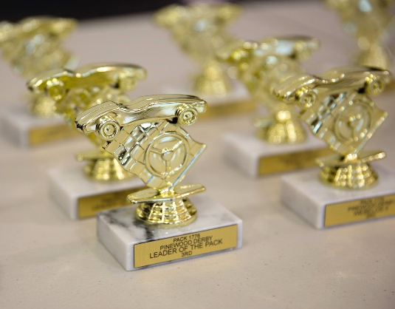
Awards
A few weeks before the race, check the inventory in the shed first. There may be medals from previous years that can be reused or given to siblings. This year, for a Pack of 78 scouts, we had about 50 submissions, including siblings.
In the past we ordered trophies and medals from TrophyDepot.com; you can also try other online companies. Unit cost is based on the quantities ordered. We typically spend about $1 for medals. Trophies should have the year printed. However, leave the year off the medals so that any extras can be used in future years.
When ordering trophies, order 1st, 2nd and 3rd place for each rank (Tiger, Wolf, Bear, Webelos I, Webelos II), plus another set for the Championship. Order additional trophies for each design category that the Derby Committee wishes to host (such as Best Design, Most Patriotic, Most Unique, Most Creative, Funniest Car, etc.). Trophies can be identical or different. There’s no hard rules; simply be price sensitive.
Order Pine Wood Derby Patches and Derby Pocket Certificates from the Scout store. The certificates are used as receipts when we impound the scouts’ cars. Don’t give away the extras, we can return them to the store!

Food
You can order pizzas from Costco or Safeway. Safeway is easier because there’s no line, you can preorder, and you don’t need a membership card. For our Pack of 78 scouts, 15 pizzas is enough; order 6 pepperoni and 9 cheese. Ask the store to cut them into 16 slices to minimize waste. You can serve the pizzas on a small plate or large napkin and skip plates. If you choose not to offer drinks, it’s helpful to offer cups for the water fountain. Most people don’t remember to bring their water bottles, even after multiple reminders.

Car Cutting
Building the car can be very challenging, especially when families don’t have access to a saw to cut the wood block. We gain better participation if the Derby Team can help arrange “car cutting days”. This can be done by: 1) asking parent volunteers that have the tools and the skills to help. (Be sure to give them extra kits in case they make mistakes). 2) checking our District website and local scout stores for free Derby Workshop Days or 3) asking the local hardware stores like ACE for help.
This year we worked with Alamo ACE Hardware to cut the scouts’ cars for $5 per car. Our parents love the service. However, please remind the parents that if they sign up, they need to show up! The store manager was annoyed because he hired extra staff to help, but many parents that signed up didn’t show.
Here’s a sample email that went out to the Pack:
Optional Pinewood Derby Car Cutting at Alamo Hardware
If you need help cutting the wood block, you can take it to Alamo Hardware (AKA Ace Hardware, across from the Blackhawk Mall) on Sunday, January 10 at 6:00 pm or Monday, January 11 at 4:00 pm. The store staff will cut each car for $5. You can also use their equipment to finalize a design, sand, and fine-tune various details. To minimize wait time, advance sign-up is required. The store staff can cut up to 5 cars every 15 minutes. If you wish to cut more than one car, please sign up for more than one slot.
- Scouts must pre-mark their block where they want the cuts made. Don’t forget to include places for the weights.
- No metal or wheels can be attached to the wood block before the cut.
- Please be respectful while in the store; Scouts must be supervised by an adult at all times.
- Please remember to pay the cashier $5 for each cut derby car.
Yours in Scouting,
Pack 1776 Leadership Team

The Qualification Process
Because Pack 1776 is a large pack, the qualifying inspection and weigh-in will take time. Make it a separate event the day before. This can easily be hosted at someone’s garage or front yard. We typically offer three hours on a Saturday for people to come by. Have at least two volunteers manning this event.

Before the Qualification Day
Gather the complete list of cub scouts and assign each scout a number. The number associated with the scout will be the number assigned to their car. Make space on the sheet for the car name that scouts will give their cars. Print and bring the list for the qualification.
Transfer the Derby Car trays, tables and weighing machine from the Pack shed to the qualification location.
OPTIONAL: Have glue guns, glue sticks, crazy glue, graphite lube, sandpaper and extra weights available so scouts that have lightweight cars or loose parts can repair their cars before turning them in. There’s also a blue “test track” in the shed. You can set it up for the kids to try test running their cars.

Check List:
- At least two volunteers for this event.
- Table and chairs for the volunteers to do their work.
- A reliable scale which is stored in the Pack shed.
- Special ruler to measure the cars.
- Pocket certificate and Derby Patch
- Small stickers to assign a unique number to each car for identification.
- A printed list of scouts with pre-assigned numbers and space to write down the name of their cars.
- Optional: “test track,” glue guns, glue sticks, crazy glue, graphite, sand paper, weights.

Qualification and Impound Cars
Once scouts turn in their cars, they cannot touch them again until after the race.
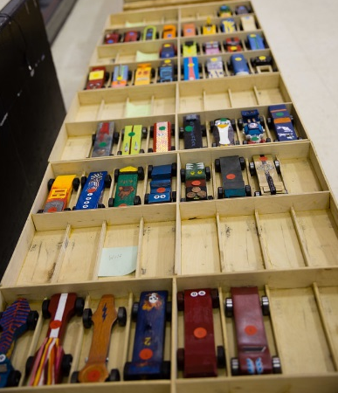
Here’s the qualification process:
- Make sure the car qualifies. If not, scouts have until the end of the qualification time to fix it. If repairs are not possible, scouts can choose to race their cars in the Siblings / Outlaw heats.
  - The overall length of the car does not exceed 7 inches.
  - The overall width of the car does not exceed 2 ¾ inches.
  - The car must have 1 ¾ inch clearance between the wheels.
  - The car must have 3/8 inch clearance underneath the body so it does not rub on the track.
  - The car’s weight cannot exceed 5.0 ounces.
  - All added parts and weights must be passive (i.e. non-removable, non-magnetic, non-electric, non-sticky, etc.)
  - The official pine wood block must be used. Store-bought pre-shaped car bodies are NOT allowed.
  - Official BSA wheels must be used. The wheels may not be cut, drilled, beveled or rounded. Seams and imperfections from the wheels may be removed.
  - The axles may be polished and lubricated. Only graphite (or dry lubricants) allowed.
  - At least three wheels need to be in contact with the track; the wheels cannot be canted.
- Ensure that each car has a scout number sticker.
- Note car name in the printed sheet.
- Provide scout with pocket certificate with car number and a Derby Patch. Do not give the Derby Patch to siblings; they are reserved for Scouts. Siblings will receive a medal at the race.

Generate Race Schedule
We need a laptop that runs Windows 7, 8 or 10, and has a DVD / CD drive and a USB port. Load the software called Grand Prix Race Manger v12, also stored in the shed. If you need a newer version, allow time for ordering the software. We do not have the previous order records so any reorder will be new (versus an upgrade).
Manufacturer: Lisano Enterprises
10190 Knoll Circle
Highlands Ranch, CO 80130
Web site: http://grandprix-software-central.com/
Email: support@grandprix-software-central.com
Install and setup the race software. Enter all the details regarding car name, car number, and scout name; generate the race schedule.

Day of the Race
Arrive three hours before the race to set up the track, projector and room. The aluminum track is stored in the shed inside two large wooden boxes. You will need a truck to carry these boxes to the MPR. Ideally, have four strong volunteers for this job. (It would be nice to carve out holes in the boxes so that they can be lifted easily.)
Once you set up the track, run multiple tests using sample cars (rather than scouts’ race cars) to make sure that the gates work properly and the times record correctly.

Materials Needed
- Small Phillips screwdriver (to secure the starting switch).
- Blue tape.
- Duct tape to cover cable and wires on the ground.
- Crazy Glue for emergency car repairs.
- Level.
- Socket wrench for any loose bolts on the tracks.
- Laptop with Grand Prix Race Manger v12 loaded.
- Cones and rope with flags, to keep the scouts away from the track.
- Race cars
- Tracking list of scouts, car numbers and car names.
- Pizzas.
- Optional: music.
- Optional: games or playdough for bored siblings and scouts.

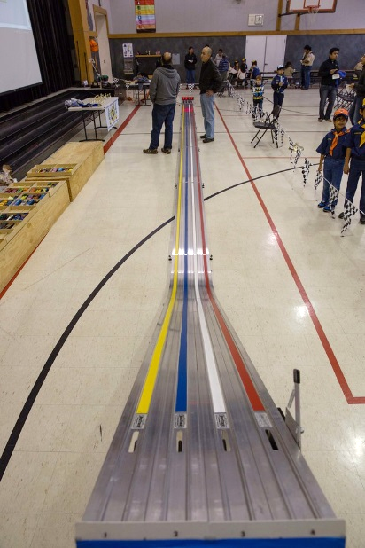
To assemble the Pinewood Derby 49’ BestTrack:
- Assemble the starting gate and attach the curved piece.
- Assemble and align track with tiles in MPR to make it straight.
- Use binder clips to secure track pieces to each other.
- Level track.
- Attach timer to track, with the LCD facing the starting gate. Note: it may take several attempts to align properly.
- Align the “Stop System” at the end of the track. The Stop System rests on the end of the track. Test that it is centered properly (run a couple of sample cars down the track) and tape in place.
- Clean debris off the track with a paper towel; if necessary, use only Simple Green cleaner.

ESS Starting Celluloid
- Attach starting switch with two screws (in blue tape).
- Attach power cord and remote starter.
- If switch breaks, buy another at Radio Shack.

Timer
- Attach separate cord (speaker wire) from starting switch to timer.
- Attach USB cable to laptop (will not work unless the cable driver is first installed).
- Attach power cord.
- Test with software for compatibility.

During the race, each car will run multiple heats using the track rotation system to ensure fairness. Only the best time will be used. If a car does not cross the finish line, the Derby Committee must help it cross so the software can complete the heat and display the results.
A few Webelos II scouts can be the car runners, carefully collecting the cars at the finish line and putting them in the staging area.
The top three cars from each rank should be put aside for the Championship Race later. Do not allow the scouts to take them home or play with them.

Championship Race and Awards
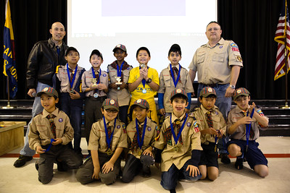
Once all the ranks, siblings, and adults complete their races, the top three winners of each rank are reentered into the software for the championship race. Siblings and adult cars are not included in the championship.
While the data is being entered, the Cub Master should give out trophies for the design category winners, and winners of each rank. This is a great time to call forward all the scouts of each rank, give them their medals, and take a group picture. Make any Pack-level announcements at this time.
Cleanup
After the race, invite the entire Pack to help clean up. Scouts can help put away the chairs while the adults help with the heavier items like the track. All derby cars should go home with their scouts. Any unclaimed cars may be used as test cars for future setups. Supplies should be packed away neatly and labeled clearly before storing in the shed. Be sure to separate race specific materials (i.e., medals and banners) from general supplies (i.e. plates, duct tapes and flags).

