Directions & Map to USS Pampanito

From Golden Gate Bridge (North Bay)
- Coming off the bridge, bear left and look for Marina off ramp
- Follow Marina Blvd. along waterfront—it will curve around Safeway, onto Laguna St. and up to Bay St.
- Turn left on Bay St. and proceed to Taylor St. (about 10 blocks)
- Turn left on Taylor St. and go 4 blocks
- Pier 45 and the Pampanito will be directly in front of you, at the foot of Taylor St.
From Interstate 80/Bay Bridge (East Bay)
- From West 80/Bay Bridge, take the very first right side exit—Fremont/Folsom
- Stay to the right towards Folsom, then turn left onto Folsom. Follow the street to the waterfront at Embarcadero. Turn left onto Embarcadero.
- Follow Embarcadero around the city waterfront all the way to the Fisherman’s Wharf area.
- Turn right at Taylor St.
- Pier 45 and the Pampanito are at the foot of Taylor St.
From Highway 101 (Peninsula)
- Follow Highway 101 up to the split with Interstate 80
- Bear right onto route 80 towards the Bay Bridge
- Take the Fourth St./Bryant St. exit—this is the very last San Francisco exit, so don’t miss it
- Bear left onto Bryant St. and follow it all the way to Embarcadero—about 6 blocks
- At Embarcadero, turn left and follow it around the city waterfront until you reach the Wharf area.
- Turn right on Taylor St.
- Pier 45 and the Pampanito are at the foot of Taylor St.
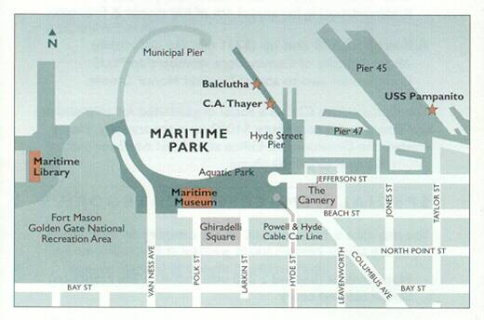

Parking Instructions

Please reference the map provided below when reviewing these instructions. Upon arrival, please check in with our staff. Follow the instructions of our staff at all times.

Parking for the Pampanito Overnight Program is in Shed A, marked with a red ‘A’ below. Shed A is the building adjacent to the Pampanito, on Pier 45. The entrance to Shed A is marked with the green arrow below, at the very end of Taylor Street. Your group can park 10 vehicles in Shed A. The cost for these 10 vehicles is already covered in the cost of your program however, if you bring more than 10 vehicles, the cost is $15 for each additional vehicle (up to 20 vehicles). We do not control the parking garage, but we have worked out a deal with the owners on behalf of our groups. The normal cost for overnight parking is more than twice the rate we’ve been able to provide to you. The provided parking spaces are not available until 6:30pm and all vehicles must be out of the garage by 8:30am the following day.
Note: If you plan on parking in the Fisherman’s Wharf area outside of this time frame, you must make additional arrangements.

Arrival: When you arrive, have your parking passes ready to show to the attendants inside of Shed A (you will receive your passes with a confirmation letter when we receive your deposit and signed contract). DO NOT UNLOAD GEAR AT THIS TIME. If the garage is closed, park your car in front of the blue garage door, and send a runner down to speak with a Pampanito staff member, they will open the door for you. Please follow the directions of our staff members, as specific changes may occur.

Please note: We provide parking from the hours of 6:30pm to 8:30am. Any cars that arrive before, or would like to remain in the Fisherman’s Wharf area longer than the allotted time, need to make other arrangements for their vehicle. Payment for additional vehicles is to be handled with the Pampanitos' staff.
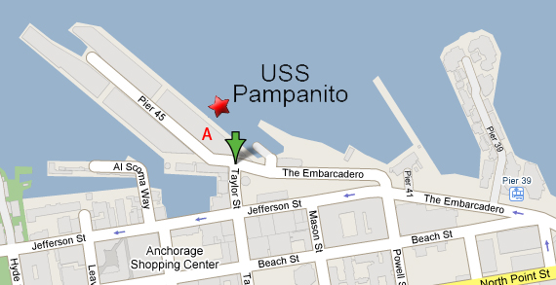
SAN FRANCISCO MARITIME NATIONAL PARK ASSOCIATION
EDUCATION PROGRAMS RELEASE FORM

In consideration of my child participating in the programs of the San Francisco Maritime National Park Association, I agree on behalf of myself and my child to assume all risks of injury to my child and agree to waive all claims, actions, damages and agree not to sue the Maritime Park Association, it’s officers, directors, employees, agents or assigns for any claims arising out of participation in the Maritime Park Association’s programs the actions of the school district or youth group’s employees, officers or agents, of the program participants.

Date of Program: ________________
Participant’s Name (Child): ____________________________
Parent’s Name: _____________________________________
We request that all parents agree to the above provision and sign above to acknowledge their agreement.
A child without a signed release form will not be allowed to participate in the program.

Signature of Parent __________________________
Date: ________________________

USS Pampanito Overnight Program

MEDICAL FORM
Each participant must complete the form. Please print.

Date of Visit: _________
Group Name: ____________________________
Participant’s Name: __________________________________
Adult Child (under 18) _______________________________
Address: __________________________________________
Emergency Contact: __________________________________
Relationship: ________________________________________
Phone number at which emergency contact can be reached throughout the duration of this program: ________________________

Do you have any physical or medical conditions, restrictions, or special needs? If so, please describe: _________________________

For parents/guardians: Occasionally photographs of the program are used in publications. If you do not want photographs containing your child’s image used, please initial here: _______________

Signature of Participant _____________________________________
(If under 18, signature of parent or guardian): ____________________
Date: _________________
Group Leaders- Please photocopy this sheet and share it with all the adults of your group!

In order to present the best and most authentic program, the following rules must be observed by all participants.

- All participants must wear pants, closed toe shoes, and have a jacket for evening. The pier may be cold. The submarine’s ambient temperature is usually in the high 60s.
- If THE GROUP wishes to bring a snack for the late evening and/or a light breakfast for the morning, please be sure that it is for everyone attending. Pizza may be ordered. Bring cash for the pizza man.
- There is NO time for dinner! Please have dinner before arriving at the Pampanito.
- Do not bring electronic devices, including cell phones, videogames, music players, etc.
- We have Zero tolerance for alcohol, drugs and weapons! People in violation will be escorted off the pier.
- There is no smoking on the pier or submarine.
- NO ONE may leave the pier after the group arrives for the program. People who leave will not be allowed to return during the duration of the program.
- All people must be 6 years old.
- No siblings are allowed unless they are full members of the participating group.
- There must be a 1:6 adult/child ratio with a minimum of 7 adults.
- The SFMNPA is not responsible for any lost or stolen items.
- Ever participant must have a completed and signed medical for and liability release form.

