July 2016 Pack News

Help Design Next Year’s Class B T-Shirt
If your scout would like to help design our Class B shirt, click here and review all the available design options. Email your scout’s favorite design and shirt color combination to gracedagen@yahoo.com. The Pack Committee will decide among the submissions at our leadership meeting on July 29. Click the attachment to see some of the ideas so far.

Webel-o-ree Registration Opens August 15th!
The 2016 Webel-o-ree is on October 1 & 2 and November 5 & 6. It’s a fun overnight outing for Webelos and their parents. Scouts can earn three adventure pins in addition to the Shooting Sports Award Patch (BB guns). Registration opens on Monday, August 15th and fills up quickly (especially the October preference). We highly encourage all Webelos to attend this event!

National Summertime Award Pins
Scouts that participate in three Pack level summer activities can earn the National Summertime Award Pin. If your scout participated in any three events this summer, please email Grace Dagen at gracedagen@yahoo.com by September 15 to receive a pin. Please note the events he participated in. The summer activities that qualify are: Cotton Candy Sale, June Pack Bike Ride, July 4th Parade, August Cub Scout Day Camp, On Site School Registration Booth and August 20th Pack Kick Off.

Recruiter Stripe
Scout can earn the recruiter stripe by getting a friend to join our Pack. Click here for more details. Email Surat Perez at surat.perez@gmail.com if your scout qualifies.

Register for Next Year Now!
Invite friends to join Pack 1776! Everyone can now sign up online. This year we’ve added Lion Cubs for Kindergarteners. New Scouts must complete a BSA form. All scouts must submit updated medical part A & B forms. The cost is $125. We are requiring a volunteer deposit of $200 for each family this coming year. Please include a separate $200 check post-dated to 4/1/2017. We will hold onto these checks and return them after you have completed your 8-hour volunteer requirement. Contact Silvia Yeh at silviayeh@gmail.com to submit your application.

August 20 Pack Recruitment Meeting
Saturday, August 20 from 2:00 PM to 4:00 PM at Coyote Creek School Blacktop
Let’s kick off our scouting year with a BANG! Please bring any boys interested in scouting and your scout’s water rocket to the Coyote Creek School Blacktop. We’ll watch them soar! For those that didn’t build one, here’s your chance! Click here for details on how. During the meeting, scouts can also build air rockets and launch them! Pack Leaders will be available to collect registration forms and answer questions. Class A uniform.

August and September Volunteer Opportunities
Can you help with these events? All your time counts toward your volunteer hours. Simply click on the link to sign up:
- August 4: New Family Orientation
- August 9: On Site Coyote Creek School Registration
- August 20: Pack Kickoff Meeting (aka Rocket Launch Meeting)
- September 9: Popcorn order pickup at Camp Herm
- September 21: Pack First Meeting, K9 Demo

July 2 Shed Clean Up
Thank you Surat, Marcos, King, Jimmy, Sameer, Revathi, Nicolas, Grace and Venkat for assisting with the shed cleanup. Now everything is much more accessible. See photo.
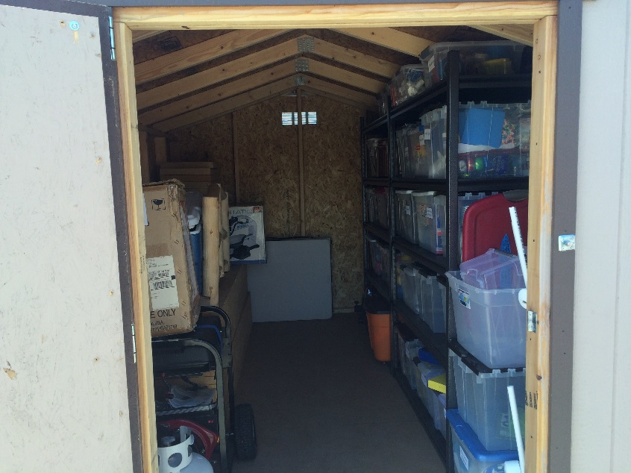

The Next Meridian District Round Table is on Thursday, August 25 at 7:30 at the LDS-San Ramon, 5025 Crow Canyon Rd. The topic will be program kickoff and recruitment. There’s free ice cream! All Den Leaders, Cubmasters, and Committee Members are encouraged to attend.

The Next Pack Leadership Meeting is on July 29 at Grace Dagen’s home. All Den Leaders, Pack Leaders, and parents who want to be more active are invited.

